* Write the following a functional interface and implement it using lambda:
  + (1) First number is greater than second number or not Parameter (int ,int ) Return boolean

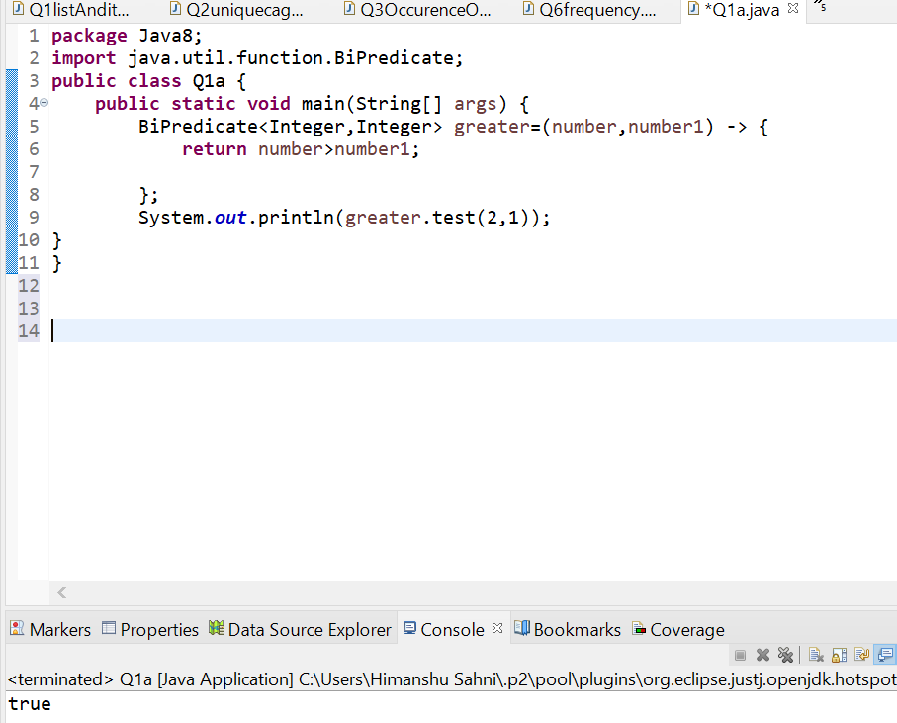

* + (2) Increment the number by 1 and return incremented value Parameter (int) Return int

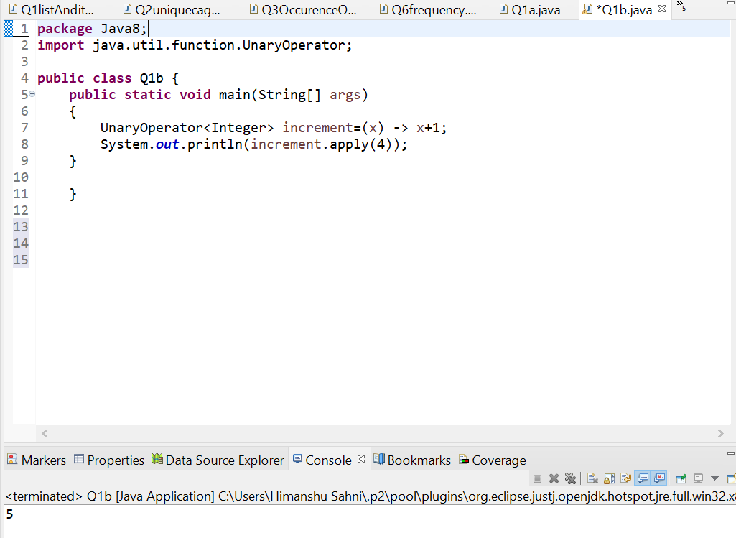

* + (3) Concatenation of 2 string Parameter (String , String ) Return (String)

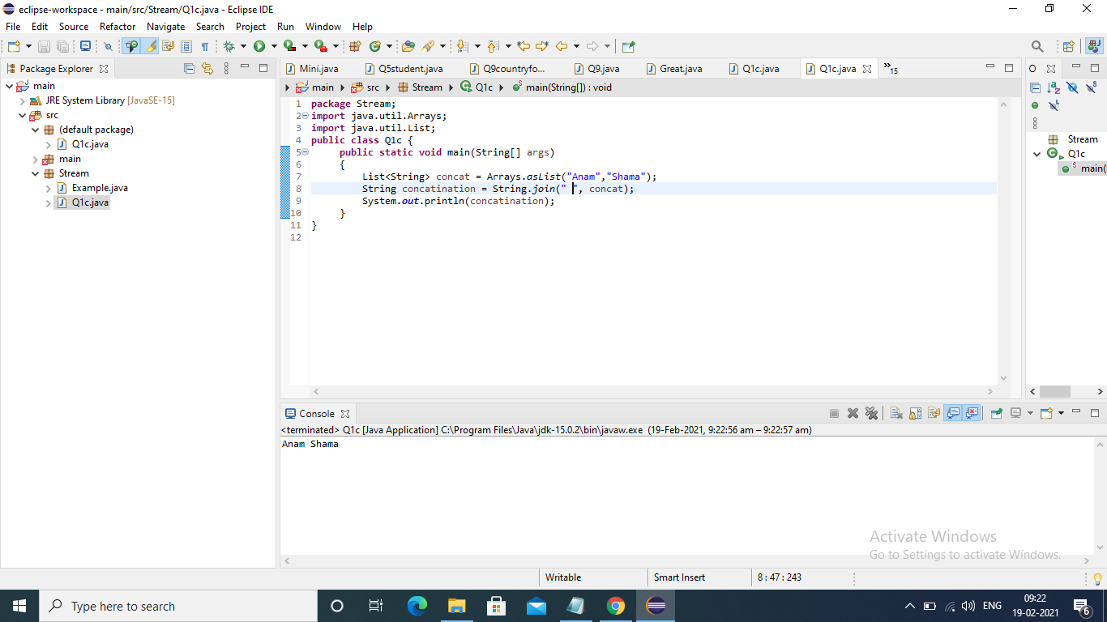

* + (4) Convert a string to uppercase and return . Parameter (String) Return (String)

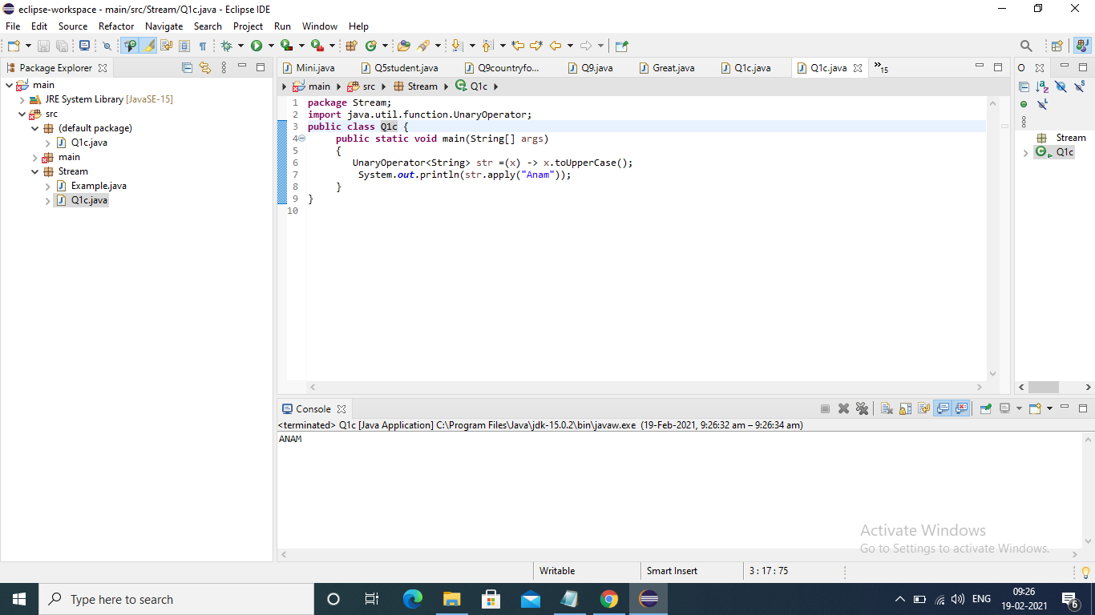

* Create a functional interface whose method takes 2 integers and return one integer.

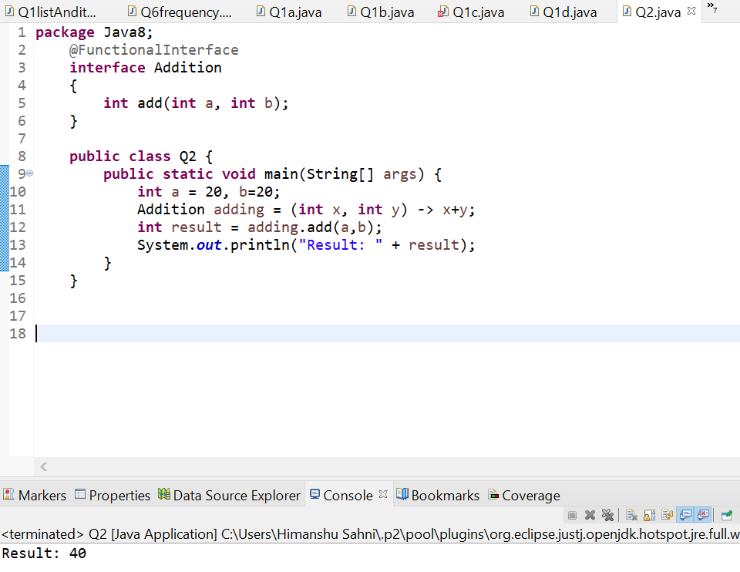

* Using (instance) Method reference create and apply add and subtract method and using (Static) Method reference create and apply multiplication method for the functional interface created.

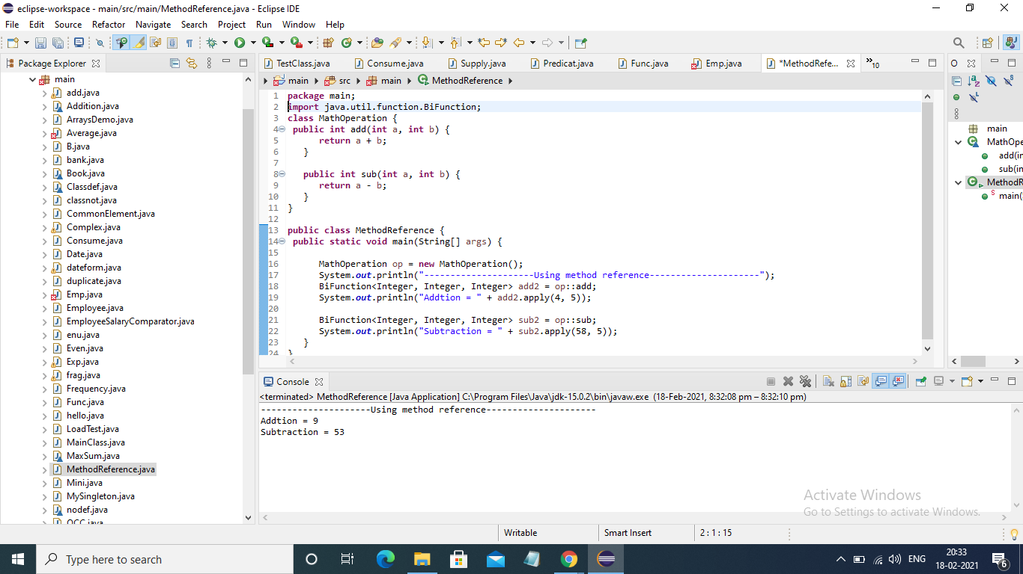

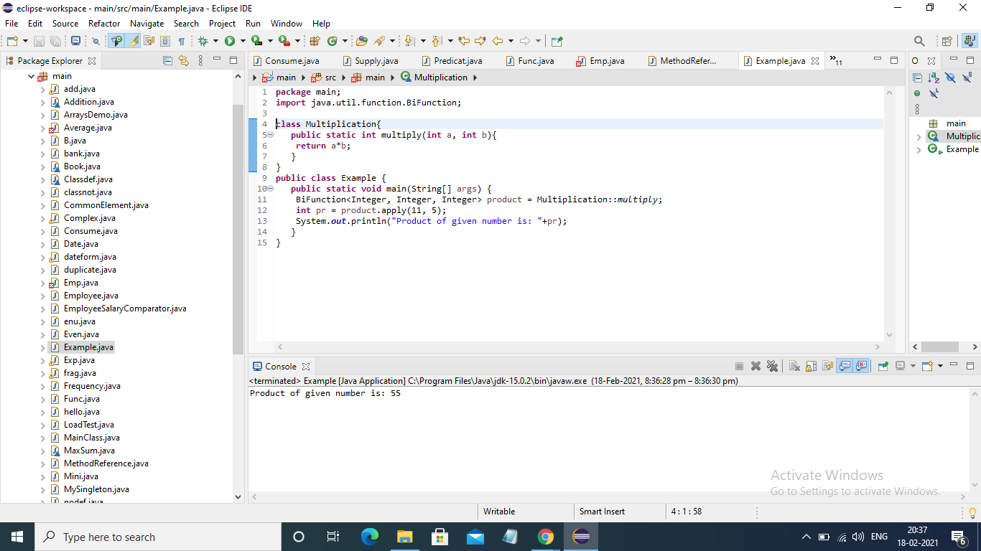

* Create an Employee Class with instance variables (String) name, (Integer)age, (String)city and get the instance of the Class using constructor reference

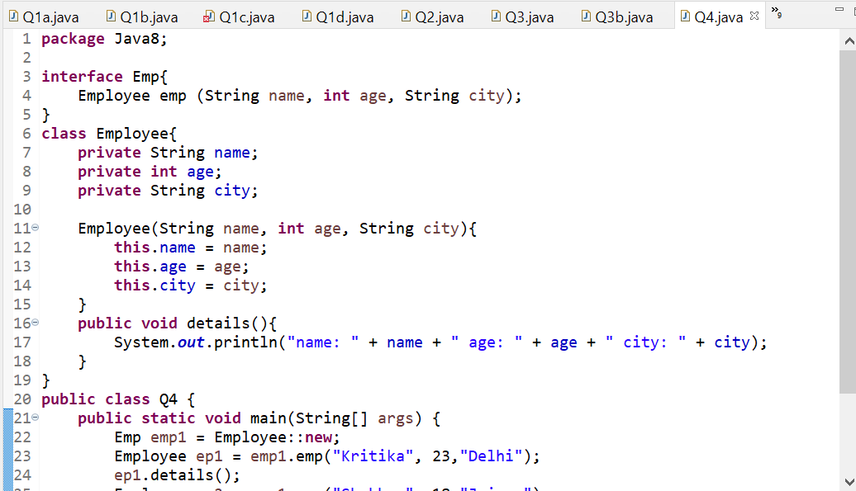

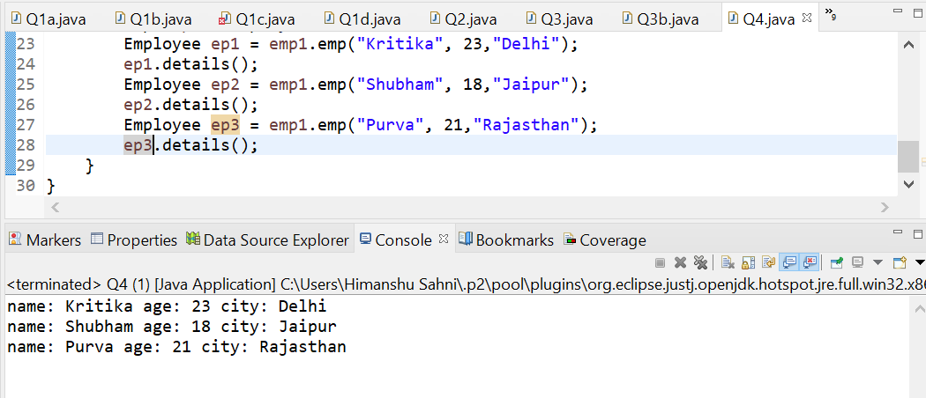

* Implement following functional interfaces from java.util.function using lambdas:
  + (1) Consumer

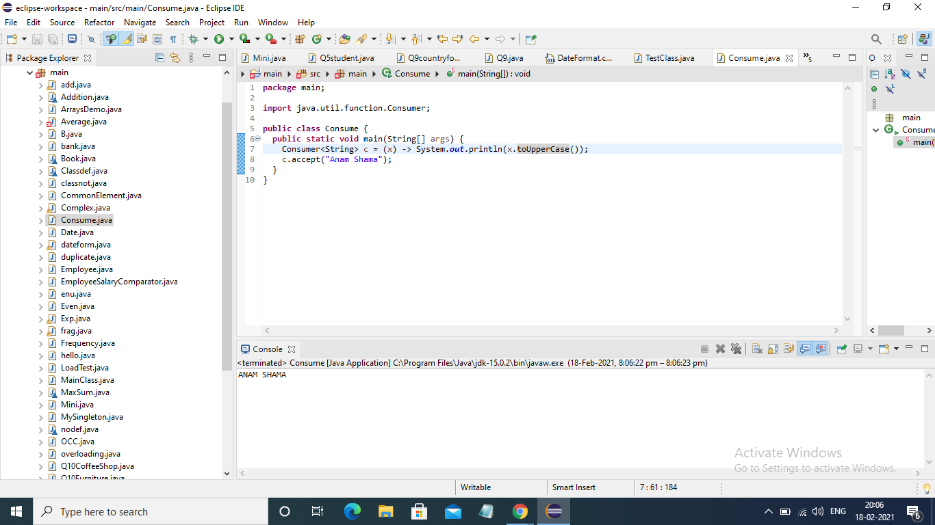

* + (2) Supplier

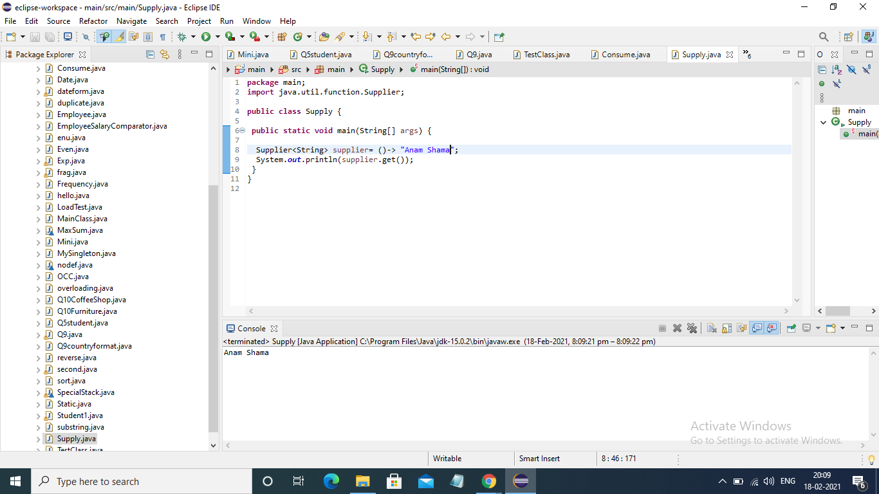

* + (3) Predicate

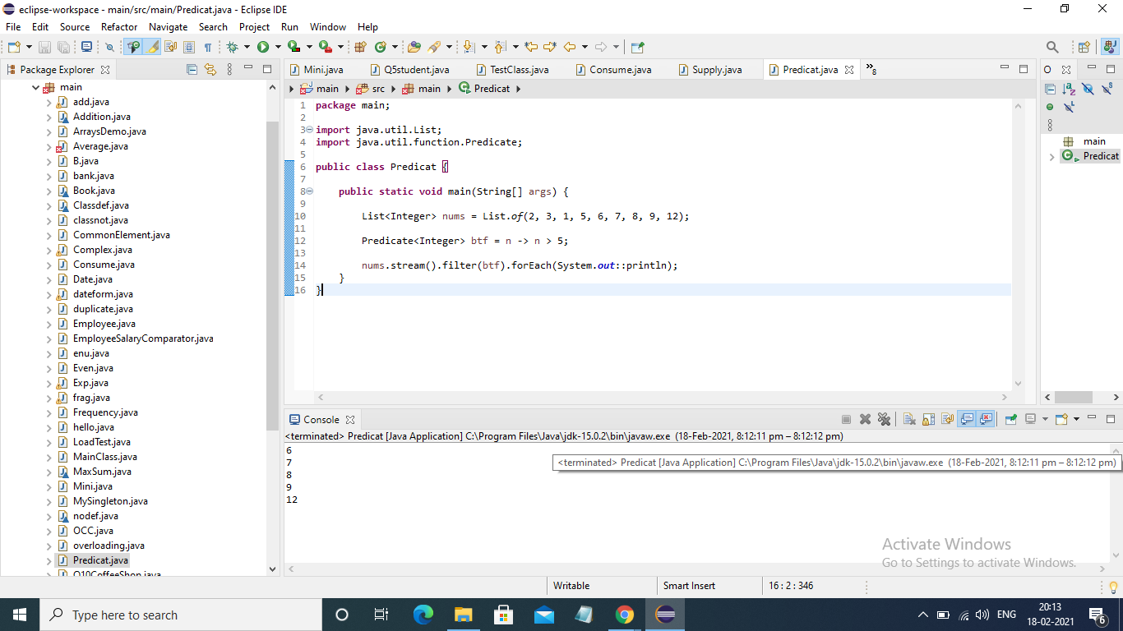

* + (4) Function

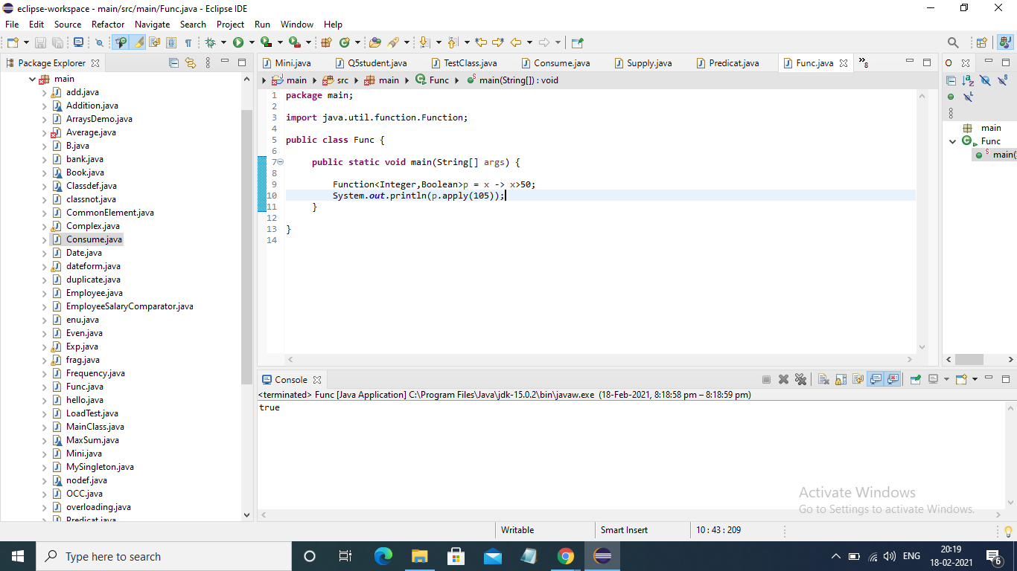

* Create and access default and static methods of an interface.

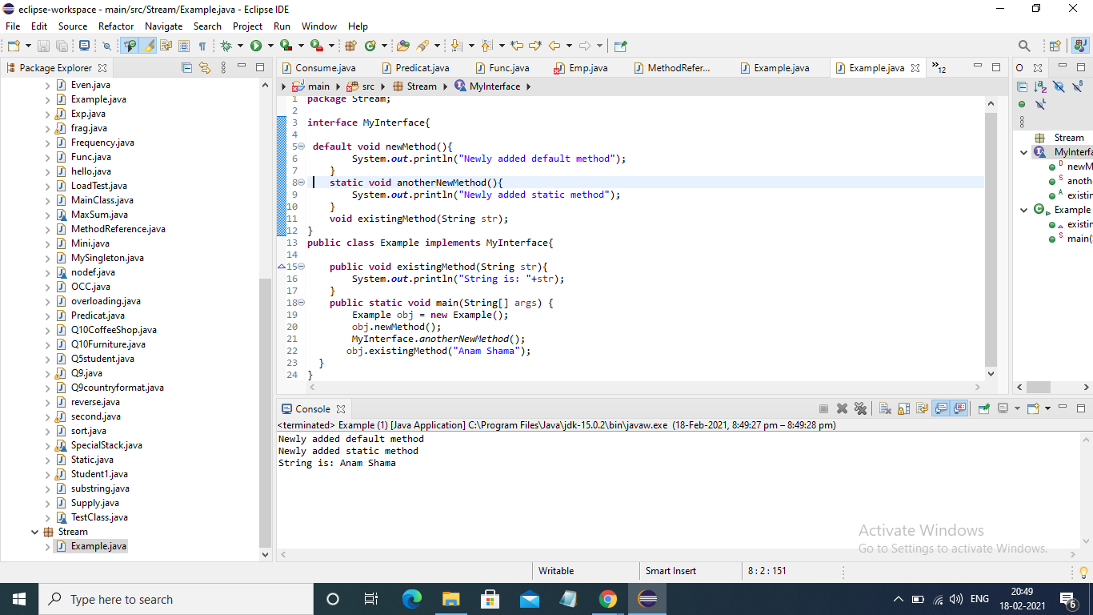

* Override the default method of the interface.

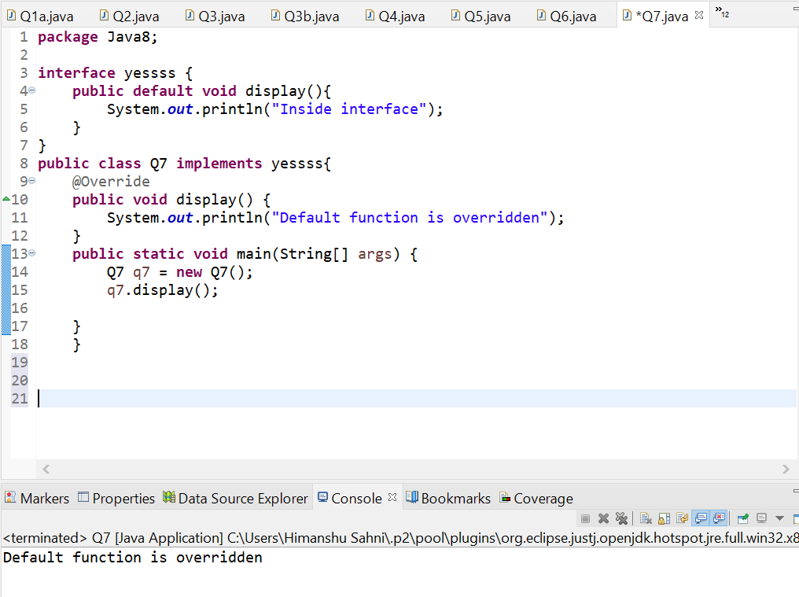

* Implement multiple inheritance with default methods inside the interface.

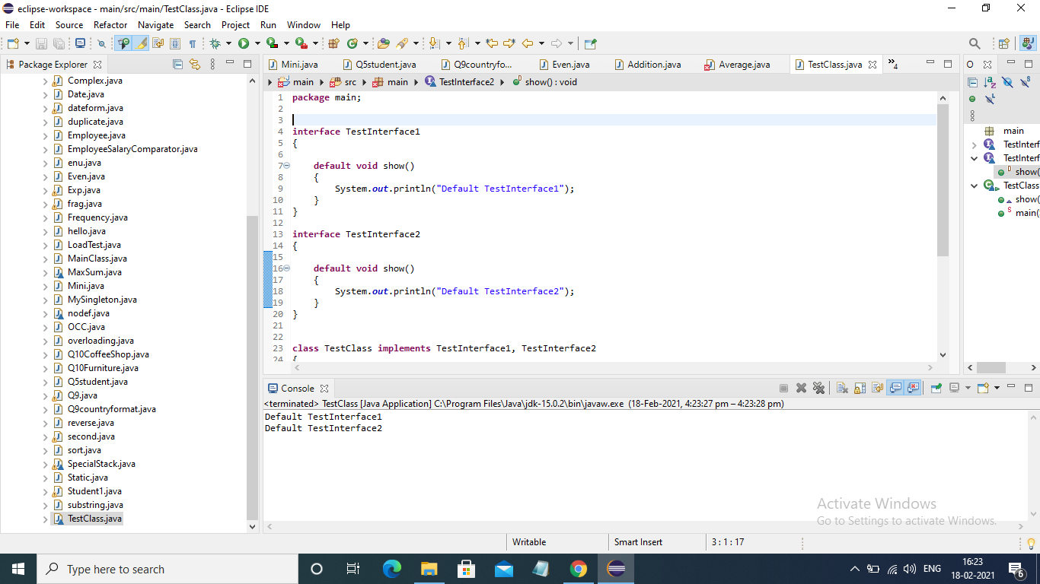

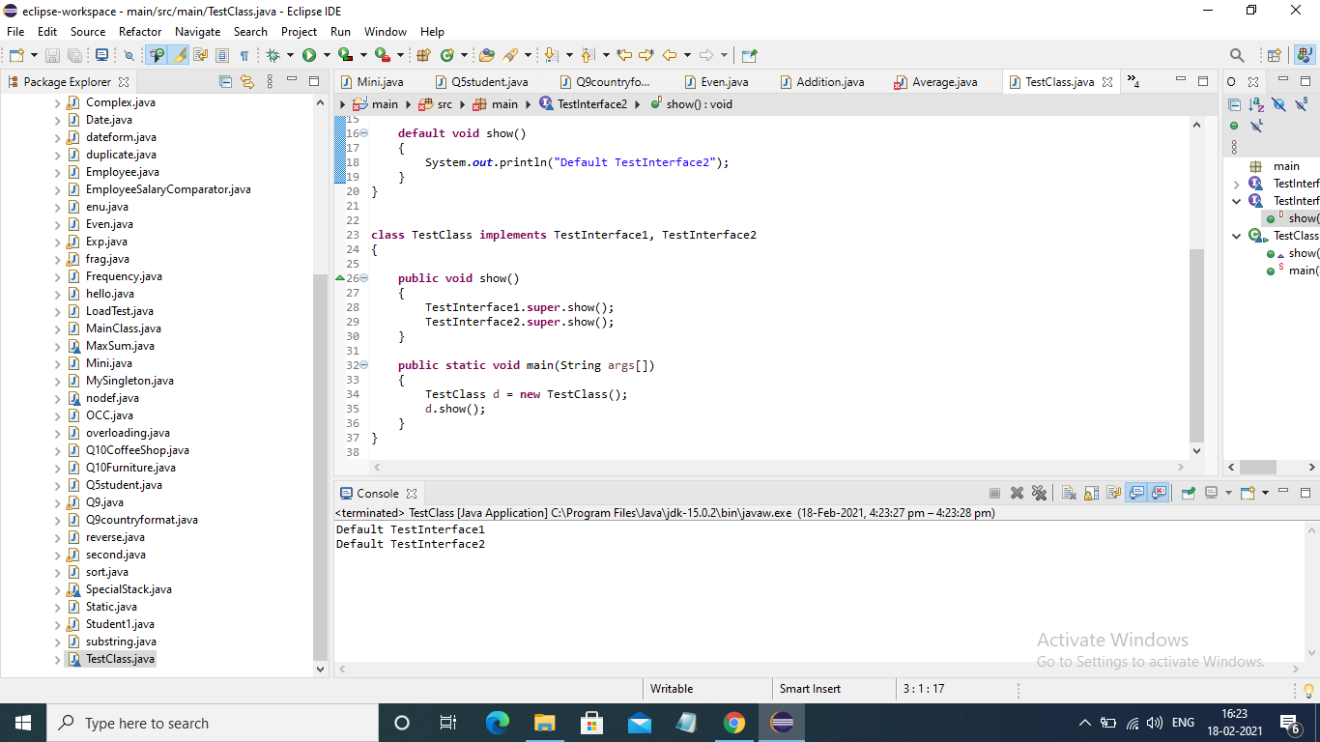

* Collect all the even numbers from an integer list.

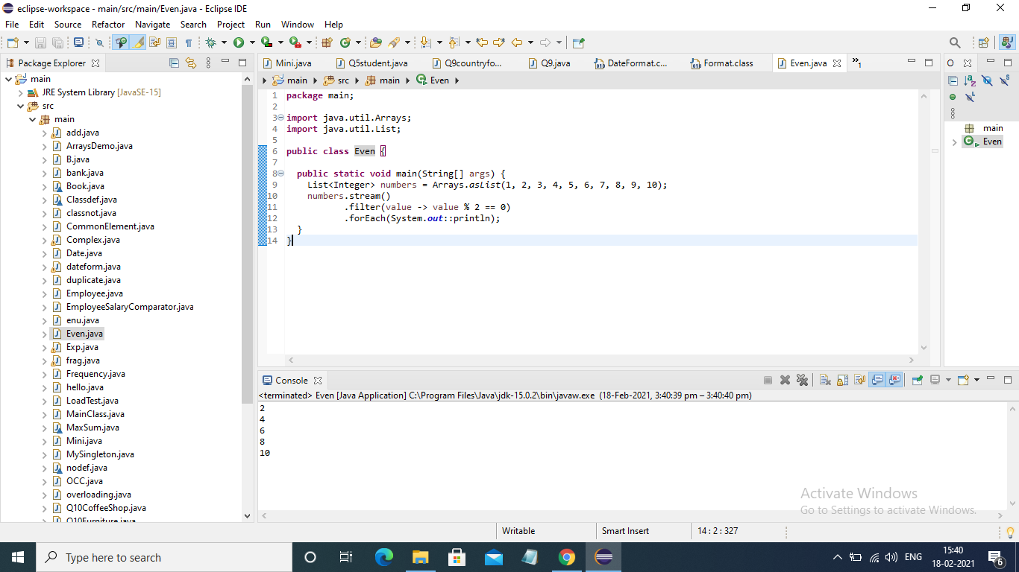

* Sum all the numbers greater than 5 in the integer list.

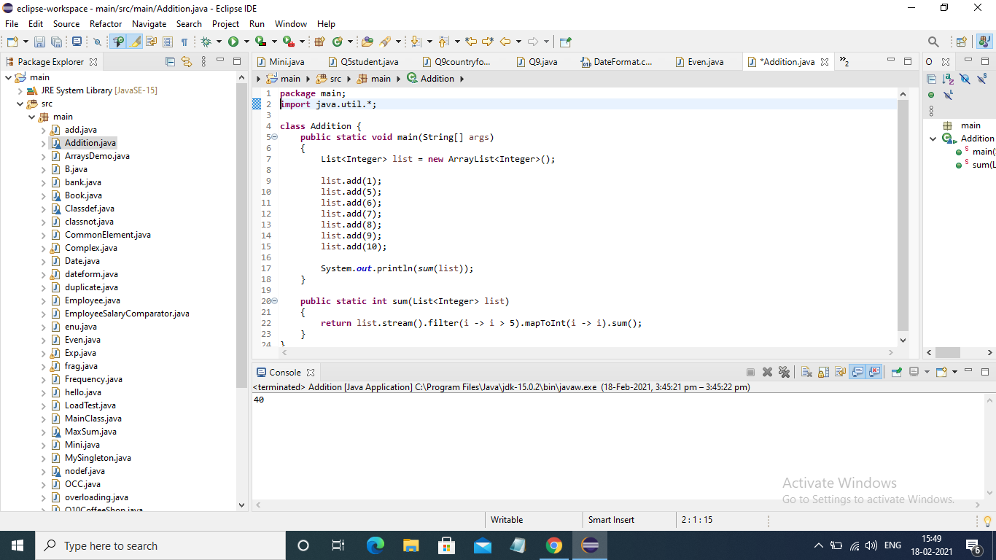

* Find the average of the number inside the integer list after doubling it.

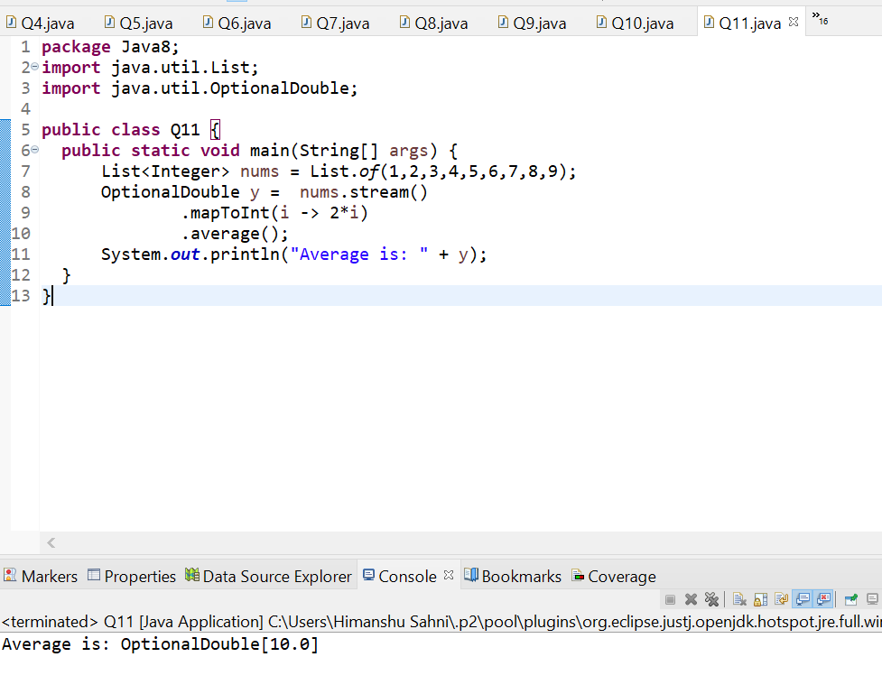

* Find the first even number in the integer list which is greater than 3.

